Permissible load (kN)

 |  |  | AP110 |  |  | Aluminium prop  EN 16031:2012
Code | AP2500-110  l = 2.5 – 1.45 m |  | AP3500-110  l = 3.5 – 1.95 m |  | AP4800-110  l = 4.8 – 2.68 m |  | AP6250-110  l = 6.25 – 4.3 m
Class | T |  | R |  | D |  | D
Weight | 15.3 kg |  | 19.2 kg |  | 24.6 kg |  | 31.2 kg
Extended Length (m) | 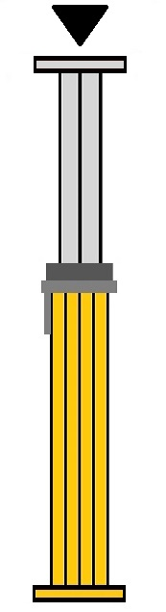 | 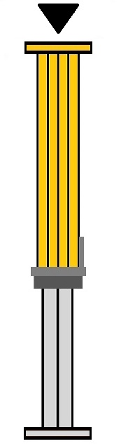
1.45 | 73 kn | 76 kn
1.5 | 73 | 76
1.70 | 73 | 76
1.90 | 68 | 76
1.95 | 67 | 76 | 88 | 87
2.10 | 64 | 75 | 83 | 87
2.30 | 61 | 70 | 73 | 86
2.50 | 60 | 64 | 64 | 83
2.70 |  |  | 59 | 78 | 86 | 71
2.90 |  |  | 56 | 72 | 72 | 70
3.10 |  |  | 53 | 65 | 63 | 69
3.30 |  |  | 50 | 55 | 55 | 68
3.50 |  |  | 43 | 45 | 50 | 64
3.70 |  |  |  |  | 46 | 58
3.90 |  |  |  |  | 42 | 50
4.10 |  |  |  |  | 38 | 44
4.30 |  |  |  |  | 35 | 38 | 56 | 44
4.50 |  |  |  |  | 31 | 34 | 53 | 44
4.70 |  |  |  |  | 27 | 29 | 49 | 43
4.80 |  |  |  |  | 25 | 27 | 46 | 42
5.00 |  |  |  |  |  |  | 41 | 40
5.20 |  |  |  |  |  |  | 36 | 37
5.40 |  |  |  |  |  |  | 32 | 34
5.60 |  |  |  |  |  |  | 28 | 31
5.80 |  |  |  |  |  |  | 25 | 28
6.00 |  |  |  |  |  |  | 23 | 25
6.20 |  |  |  |  |  |  | 21 | 23
6.25 |  |  |  |  |  |  | 20 | 22

